Supply Chain Delivery Delay & Profitability Analysis Using Python

Introduction
Supply chain management plays a critical role in ensuring smooth business operations and customer satisfaction. Delivery delays can negatively impact profitability, operational efficiency, and customer trust. In this project, a detailed analysis was conducted on a large-scale supply chain dataset to identify shipment delay patterns, profitability trends, and operational bottlenecks using Python data analytics techniques.
The project focused on analyzing more than 180,000 orders to understand how delays affect business performance and financial outcomes.

Objective of the Project
The primary objectives of this project were:
- To analyze shipment delays and delivery performance
- To identify operational bottlenecks in the supply chain
- To evaluate the impact of delays on profitability
- To generate business KPIs for performance monitoring
- To provide actionable recommendations for improving logistics efficiency

Technologies Used
The following technologies and libraries were used during the project:
- Python
- Pandas
- NumPy
- Matplotlib
- Seaborn

Dataset Information
The project used the DataCo Supply Chain dataset containing order, customer, shipping, and profitability information.

Dataset Size
- Total Records: 180,519 Orders
- Time Duration: 2015 to 2018

Important Columns Used
- Days for Shipping (Real)
- Days for Shipment (Scheduled)
- Sales per Customer
- Order Profit per Order
- Shipping Date
- Order Date
- Shipping Mode
- Customer Segment
- Department Name
- Order Region

Data Cleaning and Preprocessing
Several preprocessing steps were performed to improve data quality and analytical accuracy.

Cleaning Operations Performed
- Removed duplicate and irrelevant columns
- Removed cancelled shipment records
- Converted date columns into datetime format
- Standardized column names
- Filtered unnecessary customer information

Feature Engineering
New analytical features were created:
- Order Processing Time
- Delay Days
- Delay Flag
- Order Month
- Order Day
- Order Hour
- Profitability Flag
These engineered features helped in identifying delay patterns and profitability trends.

Exploratory Data Analysis

Delivery Performance Analysis
The analysis showed the following shipping statistics:
- Average Actual Shipping Time: 3.49 Days
- Average Scheduled Shipping Time: 2.93 Days
- Average Order Processing Time: 3.47 Days
- Maximum Delay Recorded: 4 Days
The results indicate that shipment processing often exceeded the scheduled delivery timeline.

Business KPI Analysis
Several important business KPIs were calculated during the project.
KPI | Value
Total Orders | 180,519
Late Deliveries | 98,743
On-Time Deliveries | 45.30%
Late Deliveries Percentage | 54.70%
Total Profit | $7.9 Million
Total Loss Due to Delays | $2.1 Million

Key Insight
More than half of the deliveries were delayed, which significantly affected operational performance and profitability.

Profitability Analysis
Orders were categorized into three groups:
- Profit
- Loss
- Break-even

Profitability Distribution
Category | Percentage
Profit | 80.6%
Loss | 18.7%
Break-even | 0.7%

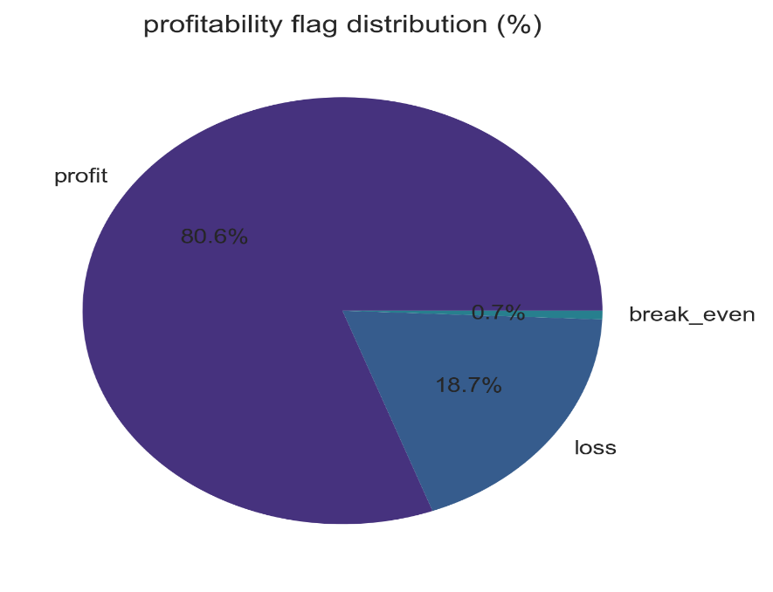

Findings
- Most orders generated profit.
- Delayed shipments reduced average profitability.
- High delays were associated with increased operational losses.
- Loss-making orders contributed heavily to supply chain inefficiencies.

Delay Distribution Analysis
The delay analysis showed the following distribution:
Delay Days | Percentage
-2 Days | 12.0%
-1 Day | 12.0%
0 Day | 21.3%
1 Day | 31.0%
2 Days | 15.9%
3 Days | 3.9%
4 Days | 3.8%

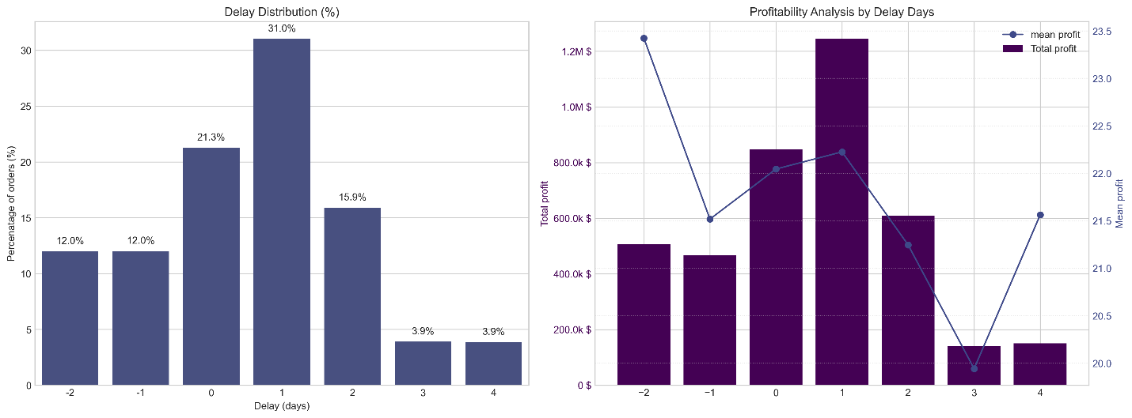

Insights
- One-day delays were the most common issue.
- More than 54% of orders experienced delays.
- Operational inefficiencies increased as delay duration increased.

Bottleneck Detection
The project analyzed delay percentages across multiple business categories to identify operational bottlenecks.

Categories Analyzed
- Shipping Mode
- Customer Segment
- Order Region
- Department Name
- Product Type
- Order Status

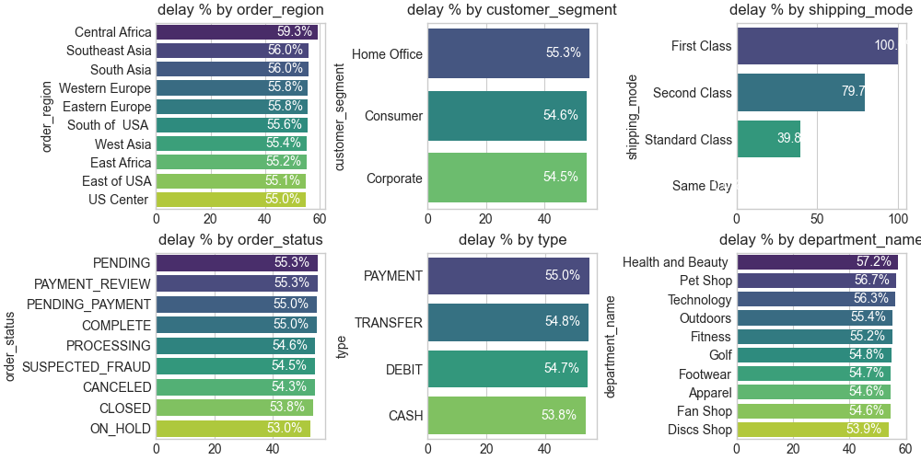

Key Findings
- Certain regions experienced higher delay percentages.
- Some shipping methods were less efficient than others.
- Specific departments contributed more to delayed deliveries.

Root Cause Analysis
A detailed root cause analysis was conducted to determine the major drivers behind delivery delays.

Major Drivers Identified
- Shipping Mode
- Customer Segment
- Department Type
- Product Type
- Order Status
The analysis helped identify high-risk operational areas that require optimization.

Time-Based Analysis

Weekly Delay Analysis
Day | Delay Percentage
Monday | 55.69%
Tuesday | 54.03%
Wednesday | 54.66%
Thursday | 54.58%
Friday | 54.53%
Saturday | 54.32%
Sunday | 55.09%

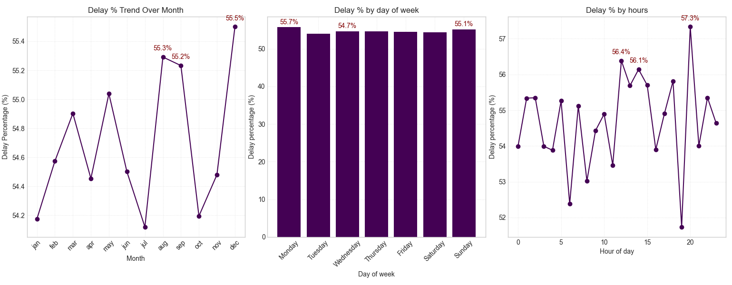

Observations
- Monday had the highest delivery delay percentage.
- Delay percentages remained consistently high throughout the week.
- Peak operational load impacted delivery efficiency.

Data Visualization
The project included professional business visualizations such as:
- Profitability Distribution Pie Chart
- Delay Distribution Bar Charts
- Profitability vs Delay Analysis
- Regional Delay Analysis
- Time-Based Delay Trend Charts
- Root Cause Analysis Charts
These visualizations helped transform raw data into actionable business insights.

Business Recommendations
Based on the analysis, the following recommendations were proposed:
- Improve shipment scheduling systems.
- Optimize high-risk shipping methods.
- Focus on reducing delays in high-risk regions.
- Implement predictive monitoring for shipment risk.
- Improve operational planning during peak periods.
- Reduce processing inefficiencies in problematic departments.

Skills Demonstrated
This project demonstrated the following skills:
- Data Cleaning
- Exploratory Data Analysis
- Business Intelligence
- KPI Development
- Supply Chain Analytics
- Root Cause Analysis
- Data Visualization
- Python Programming
- Business Problem Solving

Conclusion
This project successfully demonstrated how data analytics can be used to solve real-world supply chain problems. By analyzing delivery performance, profitability trends, and operational bottlenecks, the project provided valuable business insights that can help organizations improve logistics efficiency, reduce delays, and increase profitability.
The project highlights strong analytical, technical, and business intelligence capabilities relevant to Data Analyst and Business Analyst roles.

